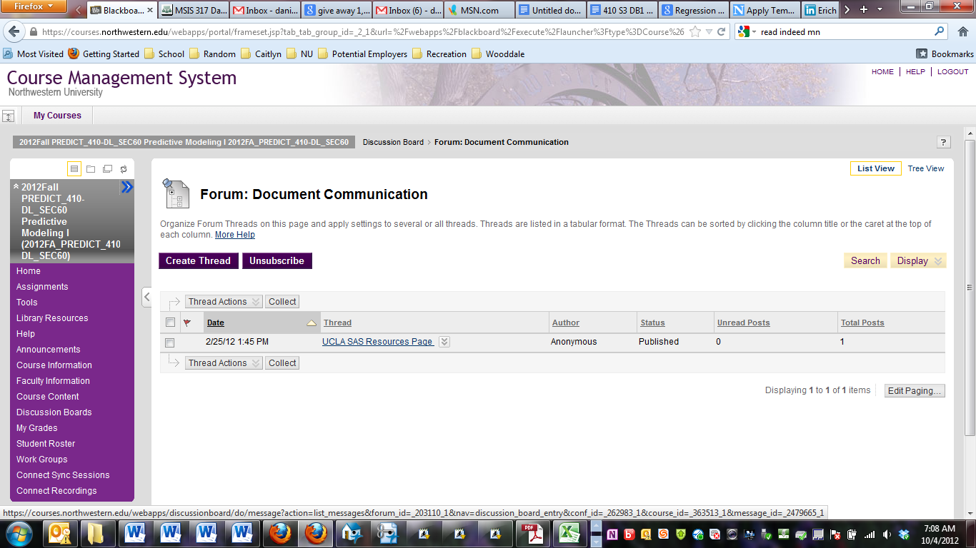

Click that button, I have already subscribed so the button has turned into an Unsubscribe button. Your button should say Subscribe.